**Flyweight Design Pattern**

**Assignment - 2**

Name - Heet Dobariya Roll No. - 22BCP177 Group - G5

* **Program :** Implement flyweight design pattern for Packaging example.
* **UML Diagram :**

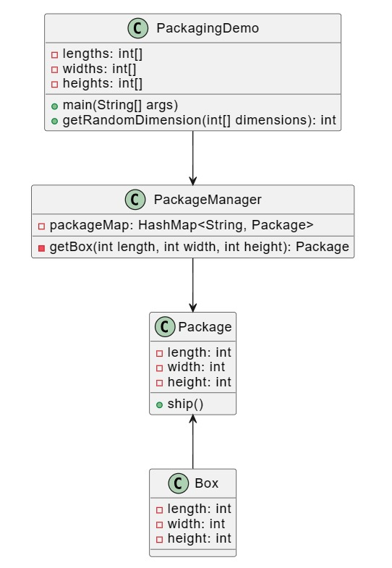

* **Code :**

import java.util.HashMap;

interface Package

{

void ship();

}

class Box implements Package

{

private int length;

private int width;

private int height;

public Box(int length, int width, int height)

{

this.length = length;

this.width = width;

this.height = height;

}

@Override

public void ship() {

System.out.println("Shipping a box with dimensions: " + length + "x" + width + "x" + height);

}

}

// Package Factory

class PackageManager {

private static final HashMap<String, Package> packageMap = new HashMap<>();

public static Package getBox(int length, int width, int height) {

String key = length + "-" + width + "-" + height;

Package box = packageMap.get(key);

if (box == null) {

box = new Box(length, width, height);

packageMap.put(key, box);

System.out.println("Creating a new box with dimensions: " + key);

}

return box;

}

}

// Main class to demonstrate the usage

class PackagingDemo {

private static final int[] lengths = {10, 20, 30};

private static final int[] widths = {5, 10, 15};

private static final int[] heights = {5, 10, 15};

public static void main(String[] args) {

for (int i = 0; i < 9; ++i) {

int length = getRandomDimension(lengths);

int width = getRandomDimension(widths);

int height = getRandomDimension(heights);

Package box = PackageManager.getBox(length, width, height);

box.ship();

}

}

private static int getRandomDimension(int[] dimensions) {

return dimensions[(int) (Math.random() * dimensions.length)];

}

}

* **Output :**

